environment
Jenkins verver: 192.168.145.78:8080
PG client server: 192.168.145.12
PG Server: 192.168.145.30
Git Server:192.168.145.78:3000

implementation process
- upload sql scripts to GIT
- Database Connectivity testing
- transfer sql scritps to PG client server
- set read sql file permission for postgres OS account
- execute sql file

SQL file normally release test

upload scripts to GIT
Create some tables and indexes in three databases (test_db1,test_db2,test_db3),details see below:

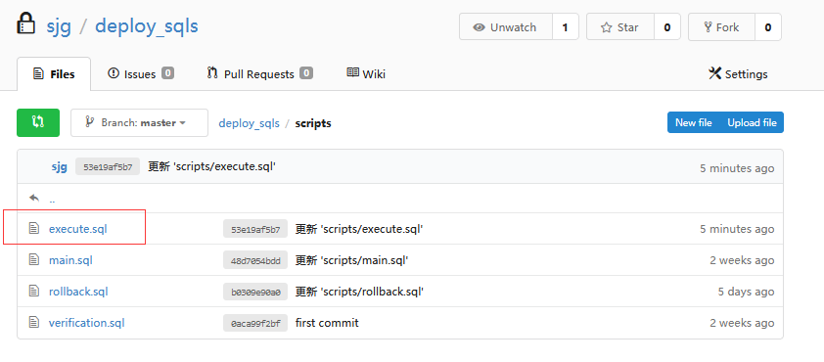

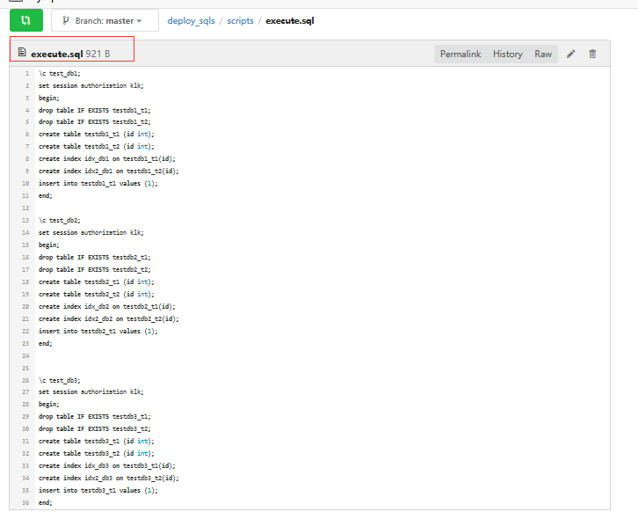

run jenkins pipline
Run pipline job to achieve the following tasks

- Database Connectivity testing
- transfer sql scritps to PG client server
- set read sql file permission for postgres OS account
- execute sql file

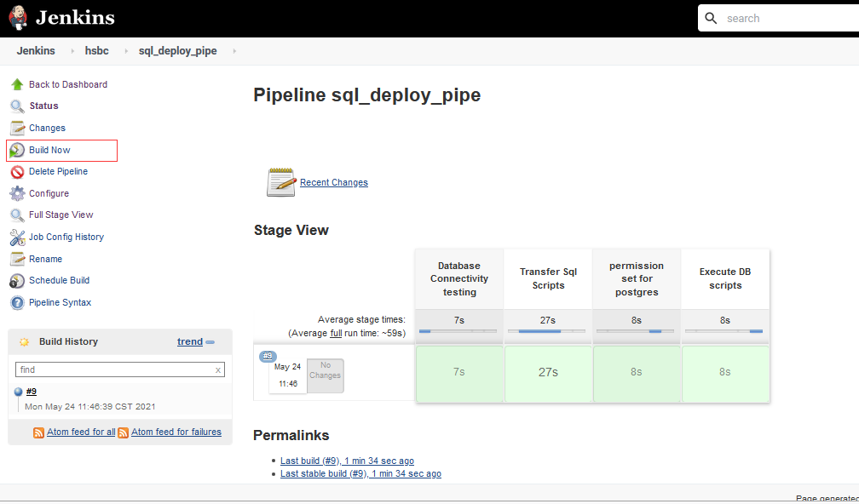

succeed:
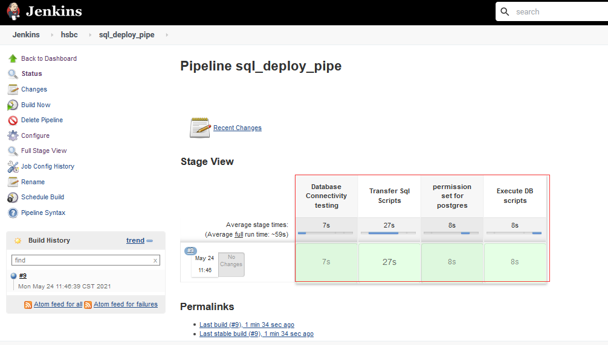

SQL file abnormally release test

upload scripts to GIT
sql error in the second database.
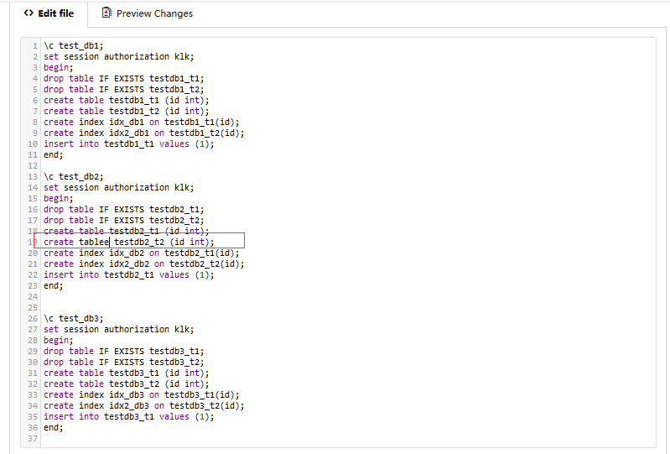

run jenkins pipline
Issue occur in "Execute DB scripts" stage.
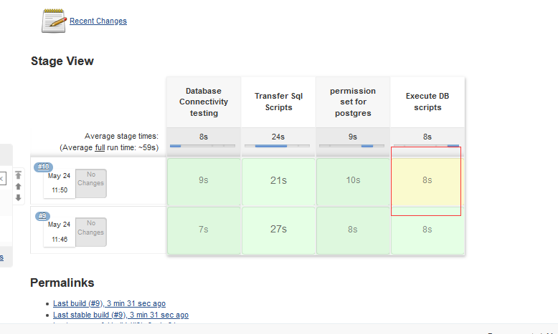
LOG:
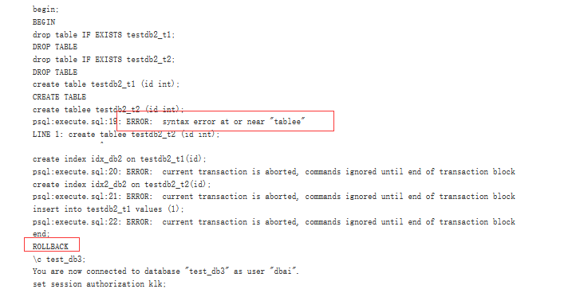

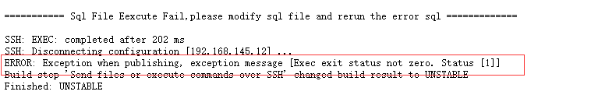

Amend
Sql in database db_test2 rollback,while sql in db_test1,db_test3 commit successfully,need to rerun sqls in db_test2.

update scripts in GIT:

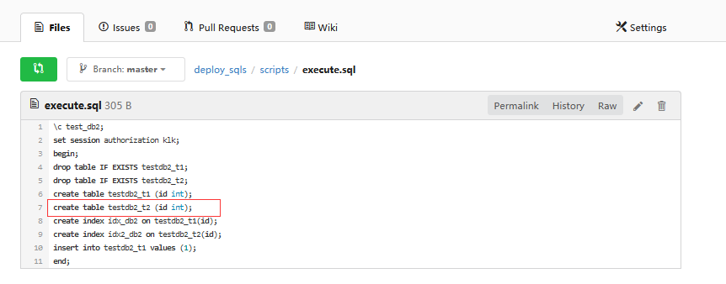
rerun pipeline job:

succeed:
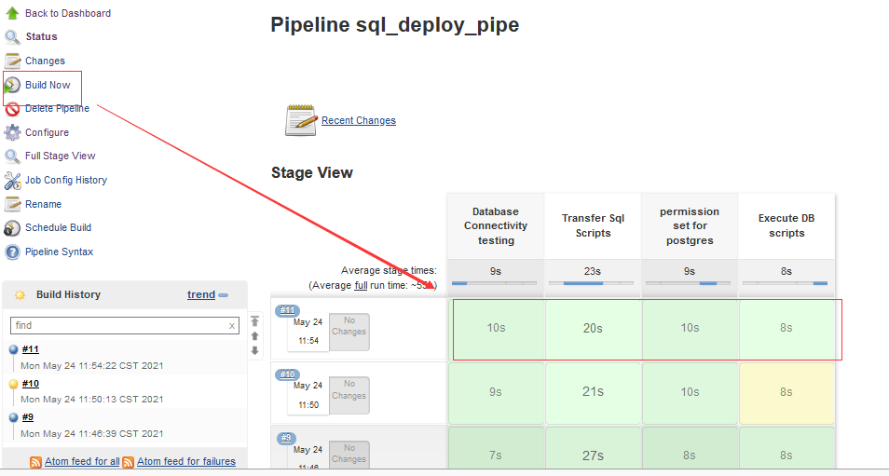

Rollback function
- Application team need to prepare scripts for rollback：

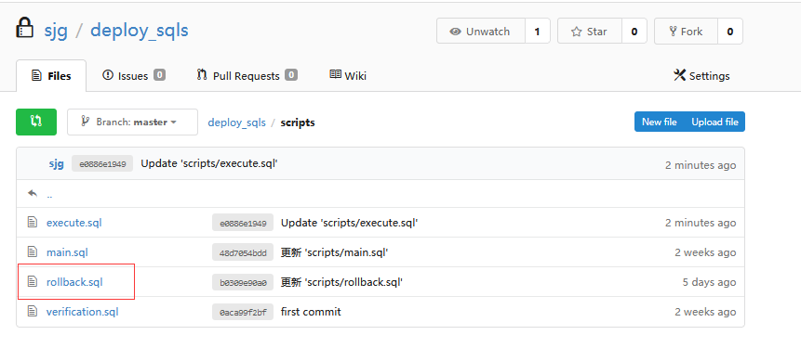
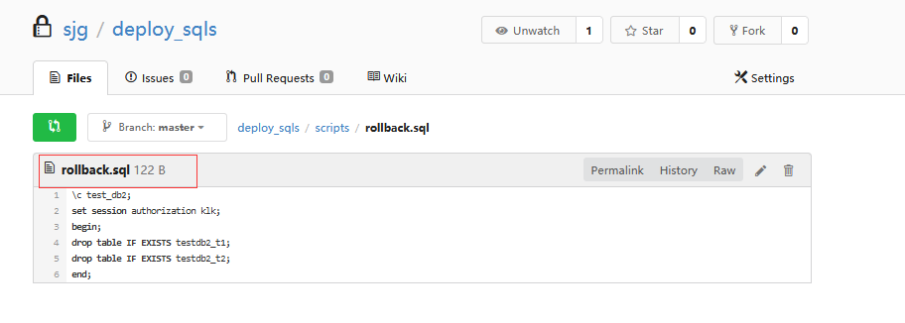

- Run the Jenkins pipeline used to rollback scripts
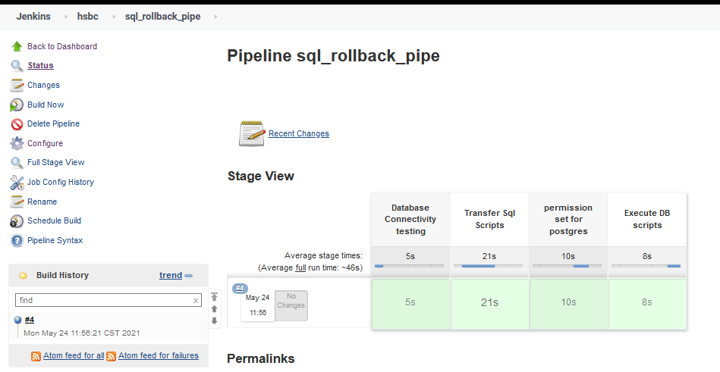

LOGS:
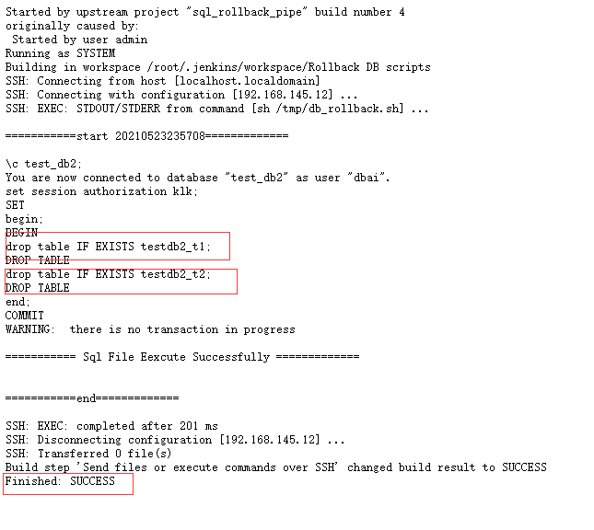

Permission control
By default, any user can have all permissions on a project, as shown below：
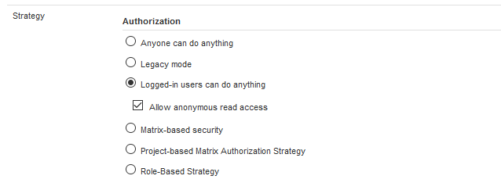

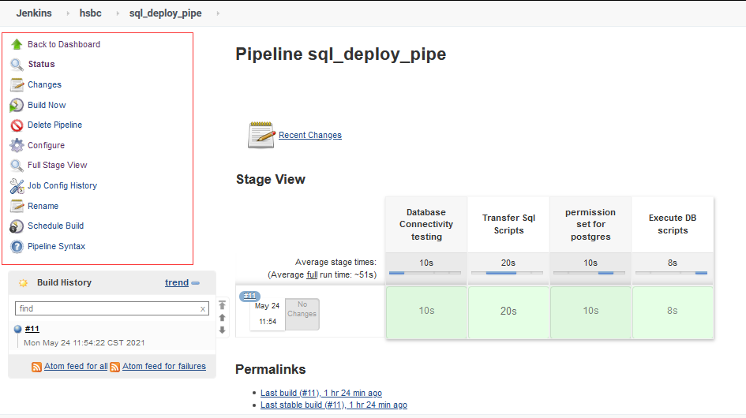

It is recommended to set the permission policy based on project authorization, and the user does not have permission to any project by default unless the relevant permissions are set .
As shown below：
Set read permissions globally for user2：
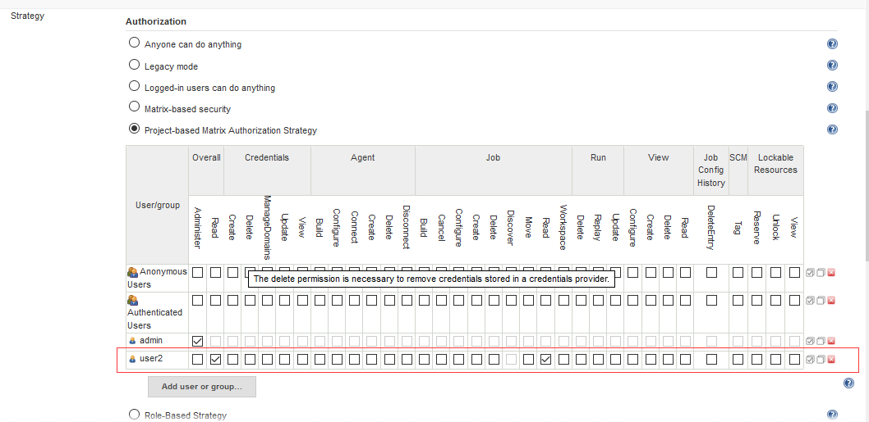

If there is no additional authorization for specific project, the user has only read permission,which is granted in the last step:

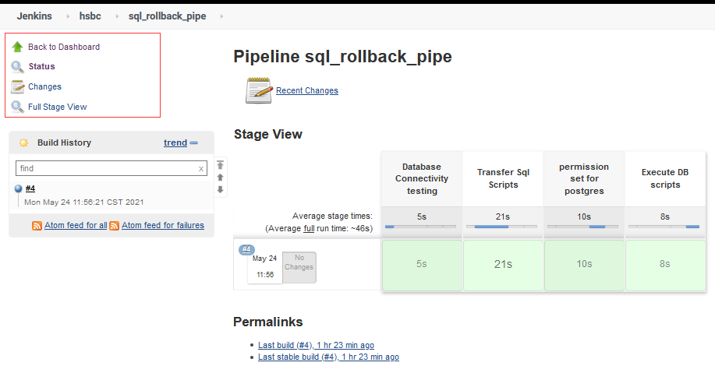

For SQL_ deploy_ Pipe project, set read, build and read permissions for user2 :
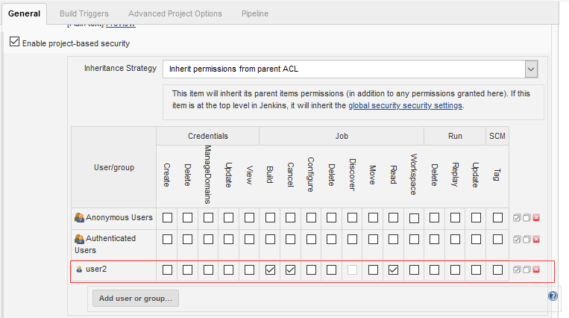

Then user2 can only perform related actions :
